**DAV PUBLIC SCHOOL, CHANDRASEKHARPUR, BBBR – 21**

**POST SUMMER VACATION TEST (20323-24)**

**CLASS-XII**

**SUB – BUSINESS STUDIES (054)**

**TIME – 1hr 30 min F: M – 40**

**General instructions:  
1. This question paper contains 25 questions.  
2. Attempt all parts of the questions together.  
3. Answers should be brief and to the point.  
4. Answers to the questions carrying 3 marks may be from 50 to 75 words.  
5. Answers to the questions carrying 4 marks may be about 150 words.  
6. Answers to the questions carrying 6 marks may be about 200 words.**

**(Q. No – 01 to 20 carries 1 mark)**

1. Through __________ the management helps individuals to develop team spirit, cooperation and commitment to group success.
2. Coordination b. Motivation and Leadership c. Effectiveness d. Efficiency
3. Providing basic amenities like schools and Creches to employees is an example of ____ objectives of management.
4. Organizational b. Personal c. Social d. Growth
5. There is a general conception that more experienced a manager is, higher will be his efficiency. This statement highlights that Management is
6. An Art b. A Science c. Both a Science and an Art d. Profession
7. Identify the point of characteristics of coordination illustrated in the picture.

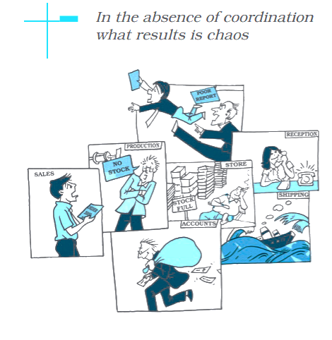

1. Coordination integrates group efforts
2. Ensure unity of efforts
3. Continuous process
4. Coordination is an all-pervasive function
5. Read the following statements: Assertion (A) and Reason(R). Choose the correct alternative from those given below:

ASSERTION (A): Management is concerned with efficient use of resources.  
REASONING (R): For management both efficiency and effectiveness need to be balanced.  
Alternatives:

1. Both Assertion (A) and Reason (R) are true and Reason (R) is the correct explanation of Assertion(A).
2. Both Assertion (A) and Reason (R) are true and Reason (R) is not the  
   correct explanation of Assertion (A)
3. Assertion (A) is true but Reason (R) is False
4. Assertion (A) is False but Reason (R) is True
5. Blessing Public School had to postpone its annual day function by a week as the Delhi Administration decided to close for four days due to an increase in pollution levels in the city. Identify the related feature of management.
6. An Intangible force
7. A Group Activity
8. A Dynamic Function
9. A Multidimensional activity
10. “Even where members of a department willingly cooperate and work, a manager has to coordinate the efforts of different people in a conscious manner”. Identify the characteristics of coordination discussed above.
11. Coordination ensures unity of action
12. Coordination is a deliberate function
13. Coordination is a continuous process
14. Coordination is an all-pervasive function
15. “The quality of workmanship and the quantity of output depends on the hard work, discipline and loyalty of the workers.” Which level of management ensures this?
16. Top Level b. Middle Level c. Operational Level d. All of the above
17. Which of the following is a function of top-level management?
18. Ensuring quality of output
19. Assigning necessary duties and responsibilities to their departments
20. Taking responsibility for all the activities of the business and its impact on the society
21. Ensuring that the safety standards are maintained within the organisation.
22. The General Manager of Uttaranchal Wood Pvt. Ltd.” Called a meeting of the Production Manager and Sales Manager both of his company. He explained to them that both of these departments are the base of the company’s success. Therefore, it is very necessary for both of them to work with coordination. Also , they were told that whatever decision they took for their respective departments; which could affect others, they must give its information to them immediately. They did the same, as a result of this, there never arose a situation in the company, when the sales orders could not be complied with because of the shortage of goods. Identify the characteristics of coordination in the paragraph given above.
23. Coordination is a continuous process c. Coordination ensures unity of action
24. Coordination is a deliberate process d. Coordination is an all-pervasive function
25. Keeping in view the changes in the consumer demands and preferences “Tastemaker Bakery” has reduced the sugar and fat content in its products. This approach of business shows that management is
26. An intangible force b. A group activity

c. A dynamic function d. A multi-dimensional activity

1. Which of the following statements does not pertain to middle level management?
   1. They are responsible for all the activities of the operational managers.
   2. They are responsible for the welfare and survival of the organisation.
   3. The interpreter the policies made by top level managers
   4. Co-operate with other departments for the smooth running of the organisation.
2. The function of management related to grouping of activities to be carried out into departments and creating management hierarchy is
   1. Planning b. Organising c. Controlling d. Directing
3. Which of the following statements is not true for lower level management?
   1. Analyse the business environment and its implications for the survival of the business.
   2. Ensure the quality of the output
   3. They strive to reduce the wastage of resources
   4. They ensure that the safety standards are maintained within the organisation.
4. Identify the process that provides the requisite amount, quality, timing and sequence of efforts, which ensures that planned objectives are achieved with a minimum of conflict
   1. Management b. Planning c. Co-ordination d. Controlling
5. Identify the level of management which does not interact with the work force directly.
   1. Supervisory management
   2. 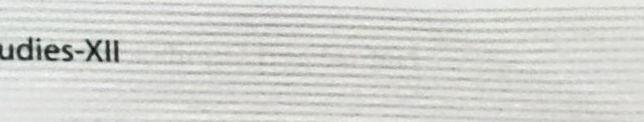Operational management
   3. First line managers
   4. Middle level management
6. It is through the process of _________ that a manager ensure the orderly arrangement of individual and group efforts to ensure unity of action in the realization of common objectives.
   1. Management b. Organizing c. Coordination d. Controlling
7. Statement I: Human resources or people are an organisation’s greatest asset.

Statement II: Despite all developments in technology “getting work done through people” is still a major task for the manager.

Choose the correct option from the following:

1. Statement I is true and II is false
2. Statement II is true and I is false
3. Both the statements are true
4. Both the statements are false
5. Rainbow 'World School' planned its annual alumni meet to get in touch with old students. Task Groups like invitation committee, decoration  committee and food committee were formed and placed under overall supervision of the official in charge of the event. Reporting relationships were established among various groups to enable smooth interaction and clarity about each group’s contribution towards the event. The management function discussed here is —
   1. Planning b. Organizing c. Directing d. Staffing
6. The process of designing and maintaining an environment in which individuals work together in groups, efficiently accomplishing selected aims, is known as:

a. Planning b. Organising c. Management d. Efficiency.

1. Captcha Ltd. is a construction company in which all the employees learn various ways of dealing with diverse situations from their seniors. Company provides financial as well as non-financial incentives. This helps the employees to grow and develop their abilities. The organisation behaves as a responsible constituent of society and always creates good quality products. It has a positive image in the market. The training modules are excellent and the employees always try to find unique ways of providing solutions in the context of rapidly changing business environment. This has helped the organisation to adjust smoothly. Identify and state three points of importance of management being highlighted here. (3 marks)
2. Why do we need to perform different functions of Management? Explain. (3 marks)
3. Rajat is working as “Regional Manager” in Tifco Ltd. Name the level at which he is working. State any three functions he will perform as ‘Regional Manager’ in this company. (4 marks)
4. Mita has a successful ice cream business at Bikaner, namely 'Smart flavours'. Her ice creams are utterly delicious. She makes ice creams from fresh milk and the same are available in a wide range of flavours and packs. She sets viable business objectives and works with the same in mind in order to ensure that the customers will come back for purchasing.

Having the first mover advantage her business was doing well. To earn higher profits, she started cutting costs. This would sometime lead to delay in delivery and the ice cream was not reaching the market in time. Over a period of time, the demand for her ice cream declined and because of it the competitors entered the market. She lost some of her market share to competitors.

At the beginning of summer season, she got back-to-back orders for supply of 4,000 ice cream packs of different flavours for special occasions. To ensure that the task was completed and orders delivered in time she hired additional workers. She was, thus able to produce and deliver the ice cream packs but at a high production cost. While completing activities and finishing the given task for achieving goals, Mita realized that she was ignoring one of the important aspects of management.

Identify the aspect of management that has been ignored by Mita. Also explain the same with the help of an example. (4 marks)

1. “Management is a profession like medical or legal profession”. Do you agree with this statement? Give any five reasons in support of your answer. (6 marks)