**DAV PUBLIC SCHOOL CHANDRASEKHARPUR, BBSR-21**

**POST SUMMER VACATION TEST , 2023-24**

* **Check that this question paper contains 5 printed pages.**
* **Check that this question paper contains 4 sections comprising 25 questions.**

**CLASS – XII**

**SUB: BIOLOGY**

**Time : 1 Hour 30 Minutes Maximum Marks:35**

**General Instructions:**

**1.The question paper contains four sections.**

**2.Section A has 20 questions.**

**3. Section B has 2 questions of 2 marks each.**

**4. Section C has 2 questions of 3 marks each.**

**5. Section D has only 1question of 5 marks.**

**SECTION A**

1. ‘Corn cobs have long tassels. This is because

A. they are useful in protecting the pollen grains from wetting.

B. they can easily attract insects.

C. it helps them to reach the surface of water which helps them to get pollinated by insects.

D. they can easily trap the pollen grains from air.

2. In the following diagrams (a) and (b), true homologous structures are 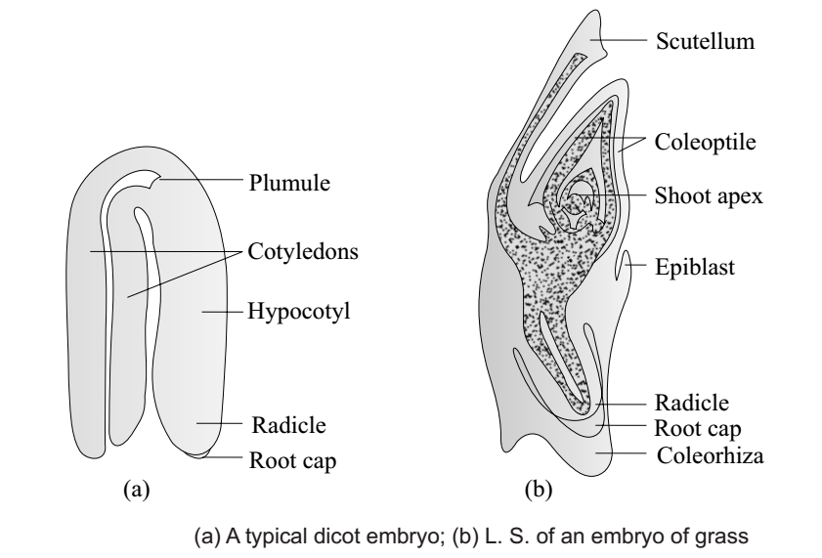

A.Coleoptile and scutellum B.Coleorhiza and scutellum

C.Cotyledons and scutellum D.Hypocotyl and radicle

3.Male gametophyte in angiosperms produces

A.Single male gamete and two vegetative cells B.Three male gametes

C.Single male gamete and a vegetative cell D.Two male gametes and a vegetative cell

4. A bilobed dithecous anther has 500 microspore mother cells per microsporangium. How many male gametophytes can this anther produce?

A. 2000 B.16000 C. 4000 D. 8000

5. Following are the pictures of *Papaver* (a) and *Michelia* (b).Choose the correct option with respect to the differrence in the structure of their ovaries.

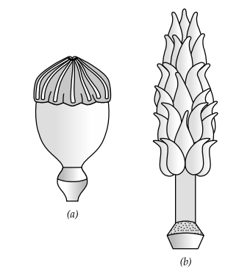

1. a-Apocarpous; b-Syncarpous B.a-Syncarpous; b-Apocarpous
2. a-Apocarpous; b-Multicarpellary D.a-Monocarpellary; b-Apocarpous

6. The following is the diagram of TS of anther. Identify the parts labelled A, B and C.

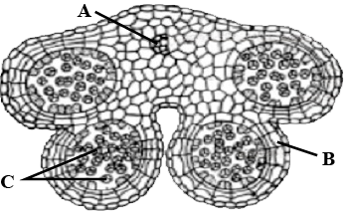

1. A-Endothecium, B-Connective tissue, C-pollen grains
2. A-Connective tissue, B-Endothecium, C-Pollen grains
3. A-Pollen grain, B-Connective tissue, C-Endothecium
4. A-Endothecium,B-Pollen grains, C-Connective tissue

7. Which of the following statement is true about chorionic villi?

A. Chorionic villi appear on morula after implantation

B. The chorionic villi and uterine tissues become interlocked and forms placenta

C. Chorionic villi develops from inner cell mass.

D. All of the above

8. In the following diagram of ovum identify ‘W’ and ‘X’.

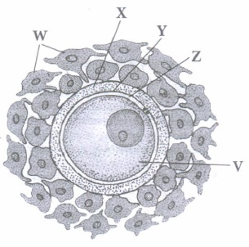

1. W-Zona pellucida, X-Corona radiata B. W-Yolk sac, X-Zona Pellucida

C.W-Corona radiata, X-Oolemma D.W-Corona radiata, X-Zona pellucida

9. GnRH secreted from hypothalamus acts at the anterior pituitary gland and stimulates secretion of

A. FSH B. LH C. Progesterone D. Both (A) and (B)

10. The concentrations of which of the following hormones will increase in the maternal blood after formation of the following structure.

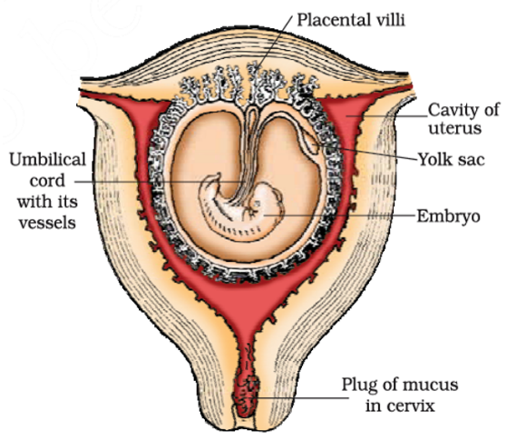

i. hCG ii. Progesterone iii. hPL iv. estrogen

A. i and ii only B. ii and iv only C. iii and iv only D. i,ii,iii, and iv

11. Acrosomal reaction of the sperm occurs due to:

A. Its contact with zona pellucida of the ova

B. Reactions within the uterine environment of the female

C. Reactions within the epididymal environment of the male

D. Androgens produced in the uterus

12. The immature male germ cell undergo division to produce sperms by the process of spermatogenesis. Choose the correct one with reference to above.

A. Spermatogonia have 46 chromosomes and always undergo meiotic cell division

B. Primary spermatocytes divide by mitotic cell division

C. Secondary spermatocytes have 23 chromosomes and undergo second meiotic division

D. Spermatozoa are transformed into spermatids .

13. Sterilisation techniques are generally full proof methods of contraception with least side effects. Yet, this is the last option for the couples because:

i. It is almost irreversible ii. Of the misconception that it will reduce sexual urge/drive

iii. It is a surgical procedure

iv. Of lack of sufficient facilities in many parts of the country

Choose the correct option:

A. i and iii B. ii and iii C. ii and iv D. i, ii, iii and iv

14. Match column I and II about Assisted Reproductive Technology and its methods and select correct option.

column -I column-II

P-IVF (i) In vitro fertilization,embryo implantion fallopian tube

Q-ZIFT (ii) In vitro fertization,embryo implantion uterus.

R-GIFT (iii) Prenatal diagnosis of foetus for genetic disorder.

S- Amniocentesis (iv) In vivo fertilization,sperm and ova transferred in fallopian tube.

A. (P - ii) (Q - i) (R - iv) (S - iii) B.(P - iv) (Q - iii) (R - ii) (S - i)

C. (P - iii) (Q - iv) (R - ii) (S - i) D. (P - iv) (Q - iii) (R - i) (S - ii)

15. The technique called Gamete Intra Fallopian Transfer (GIFT) is recommended for those females  
(a) who cannot produce an ovum  
(b) who cannot retain the foetus inside uterus  
(c) who cannot provide suitable environment for fertilisation  
(d) all of these

Question No 16 to 20 consists of two statements-Assertion(A) and Reason (R).

Answer these questions selecting the appropriate options given below.

1. Both A and R are true and R is the correct explanation of A.
2. Both A and R are true and R is not the correct explanation of A.
3. A is true but R is false.
4. A is false but R is true.

16. Assertion: InVitro Fertilization is done inside the body of the female.

Reason: Zygote or early embryo up to 8 blastomere stage is transferred to fallopian tube.

17. Assertion: Oral contraceptive pills are effective method of contraception with few side effects.

Reason: Oral pills contains hormones that regulate menstruation,inhibit ovulation and implantation.

18. Assertion: The endometrium undergoes cyclical changes during menstrual cycle.

Reason: Perimetrium contracts strongly during delivery of the baby.

19. Assertion: Ovulation takes place due to rapid increase of LH.

Reason: Estrogen level is high in the Luteal phase just before menstruation.

20. Assertion: Chasmogamous flowers usually have strikingly coloured petals and nectar glands in contrast to cleistogamous flowers.

Reason: Chasmogamous flowers avail mostly Entomophily.

**SECTION B**

21. a.Mention the names of hormones for production and release of milk from mammary glands.

b. Write the function of epididymis in male reproductive system.

22. The diploid number of chromosomes in an angiospermic plant is 16.What will be the number of chromosomes in its endosperm , antipodal cells, embryo, female gamete.

OR

Draw the structure of a mature pollen grain and label it’s parts.

**SECTION C**

23. Draw the structure of a typical anatropous ovule and label the parts which

1. Develops in to outer seed coat.
2. which forms the MMC.
3. Has the female gamete.
4. Through which pollen tube enters into ovule.

OR

a. Mention the special mode of reproduction found in angiosperms which mimics sexual reproduction.write the conditions in which diploid embryo is formed without fertilization.

b. What is polyembryony? Give example and write its advantages.

24. Give a schematic labelled diagram to represent oogenesis. Mention the ploidy at different stages.

OR

a. Mention the names and function of cells present inside seminiferous tubules of Testes.

b. i. Mention the name of the part of spermatozoa which provides energy .

ii.Write about the changes after entry of sperm in to cytoplasm of secondary oocyte.

**SECTION D**

25. Study the diagram given below representing ovarian and uterine events at different stages of menstrual cycle and answer the following questions:

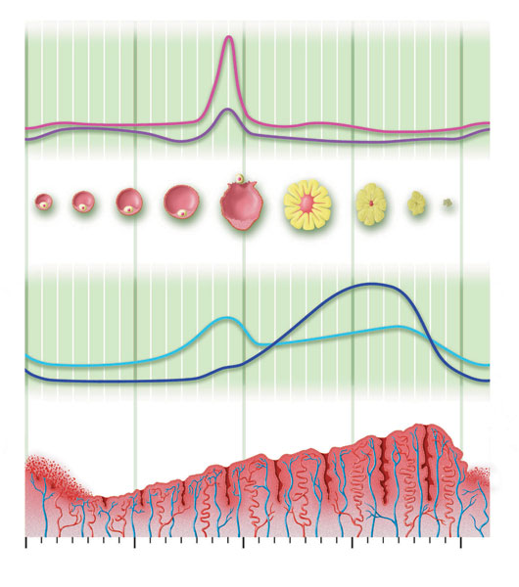

1. What role does pituitary gonadotropins play during follicular and ovulatory phases of menstrual cycle?
2. Mention the uterine events in Luteal phase of menstrual cycle. Write the names of the structure in ovary and the hormone produced influencing this.
3. How scientific understanding of menstrual cycle can act as a natural method of birth control.

OR

1. The zygote passes through several developmental stages till implantation, Describe each stage briefly with suitable diagrams with proper labeling.

ii. Where from the signal for parturition arises and name the hormone(s) involved it.

xxxxxxxxxxxxxxxxxxxxxxxxxxxxxxxxxxxxxxxxxxxxxxxxxxx