**DAV PUBLIC SCHOOL CHANDRASEKHARPUR, BBSR-21**

**POST SUMMER VACATION TEST (2023-24)**

**CLASS- XII**

**SUB: PHYSICAL EDUCATION**

**Time Allowed: 1 $\frac{1}{2}$ Hours Maximum Marks: 35**

**General Instructions:**

* The question paper consists of 5 sections and **17** questions.
* Section A consists of question 1-9 carrying 1 mark each and is multiple choice questions. All questions are compulsory.
* Section B consists of questions10-12 carrying 2 marks each and are very short answer types and should not exceed 60-90 words. There is Internal choice available.
* Section C consists of questions 13 & 14 carrying 3 marks each and are short answer types and should not exceed 100-150 words. There is Internal choice available.
* Section D consists of question no 15 carrying 4 marks each and are case studies. There is internal choice available.
* Section E consists of questions 16 & 17 carrying 5 marks each and are short answer types and should not exceed 200-300 words. There is Internal choice available.

# SECTION-A (01 MARKS)

1. The benefits of Intramural competition is/are 1
   1. Psychological satisfaction b) Opportunity for participation

c) Development of moral values d) All of the above

1. Which of these in not an objective of organizing sports day? 1
   1. All round development of students. b)Development of leadership quality
2. Development of social value. d)Advertisement of product

3. Match list –I with List-II and select the correct answer from the code given below. 1

|  |  |
| --- | --- |
| LIST- I | LIST -II |
| 1. Intermural tournament | 1. Regulates the rules of game |
| 1. Extramural tournament | ii. Within the walls of institution |
| 1. Secretary of tournament | iii. Does all planning of tournament |
| 1. Technical Committee | iv. Outside the institution |

CODES

|  |  |  |  |  |
| --- | --- | --- | --- | --- |
|  | i | ii | iii | iv |
| a | 4 | 1 | 3 | 2 |
| b | 3 | 2 | 4 | 1 |
| c | 2 | 3 | 1 | 4 |
| d | 1 | 4 | 2 | 3 |

4. League- cum –knock-out is a part of which tournament? 1

a) Knock-out b) Round Robin c) transverse plane d) Combination

5. Which of the following factors may enhance the chances of osteoporosis among 1

female athletes?

a) Insufficient calcium in the diet b) Eating disorder c) Amenorrhea d) All of the above

6. Lordosis can be corrected by 1

a) Back word bending exercise b) Forward bending exercise

c) Side ward bending exercise d) All of the above

7. In bow legs deformity there is. 1

a) Wide gap between knees b) Plane foot sole c)Knees collide with each other d) Bending to side ward.

8. Postural deformity of kyphosis is commonly known as: 1

a) Hollow back b) Hunch back c) knock- knee d) Side ward bending

9. Given below are two statements, one of which is labelled as Assertion(A) Reason (R) 1

Assertion(A): In India, women’s participation in sports in quite less

Reason(R): Indian society still does not promote or accept women’s participation in sports.

Which one of the following statement is correct.

1. Both A and R are true and R is the correct explanation of A.
2. Both A and R are true, but R is not the correct explanation of A.
3. A is true, but R is false
4. A is false, but R is true.

**SECTION –B (02 MARKS)**

10. Discuss any four objectives of Intramural. [ 0.5x 4]

11. Elaborate any two functions of sports management in brief. [1+1]

12. Suggest four corrective measures for kyphosis [0.5x4]

OR

Suggest any four correct measures for flat foot.

**SECTION –C (03 MARKS)**

13. Differentiate between menarche and menstrual dysfunction. [1.5+1.5]

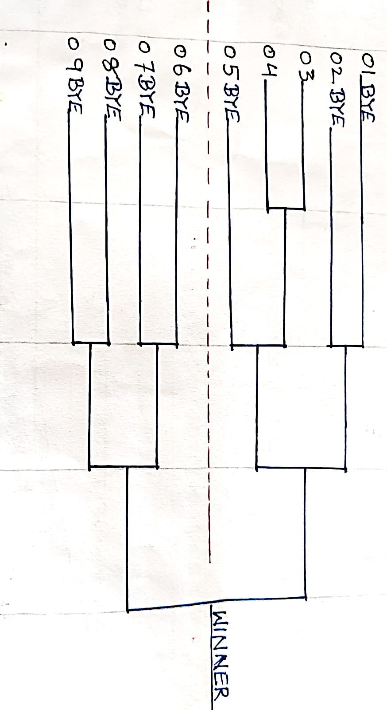14. What does league tournament mean? Draw a single league fixture for 07 teams in using cyclic method.

OR

What is seeding. Draw a knock out fixture for 9 teams, in which two teams are seeded. [1+2]

**SECTION-D (04 MARKS)**

15. DAV public School, Chandrasekharpur could shoulder the responsibility in organizing DAV Zonal Basketball tournament, in which 9 teams participated. [1x 4]

On the basis of above given picture answer the following questions.

1. The first bye goes to team no_________.
2. The formula for calculating the total no of byes is__________.
3. The 3rd byes goes to the team no______.
4. The formula for calculating the no of round is_____.

OR

The for formula for calculating the no pf teams in upper half is___________.

**SECTION –E (05 MARKS)**

16. What does knock-out tournament mean? Draw a knock-out fixture for 11 teams with all computations. OR

Define combination tournament. draw a fixture of 16 teams using knock-out cum league method.

[1+2+2]

17. Discuss in detail about common postural deformities by making the flow chart. Explain any three corrective measures for Lordosis. [2+3]